Jose Rodriguez
CSD 310 Module 2.3 Assignment
ERD
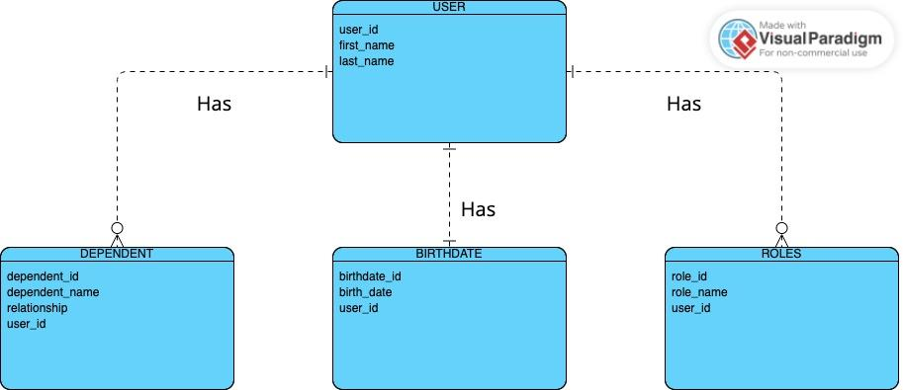

NoSQL
